ENGLISH CLUB
SD No 3 Abianbase
By Trisna
January is a very special day when Susan and Derek Cromb visited our school especially English Club that adopted by AAS. For the students in Bali, meet foreigners is a special thing. Now, English Club is in the second year. Below is the picture of English Club member year2010-2011 with teachers of SD No 3 Abianbase, Susan and Derek.

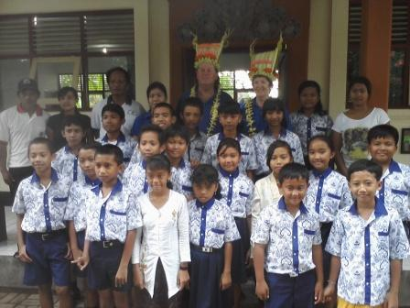

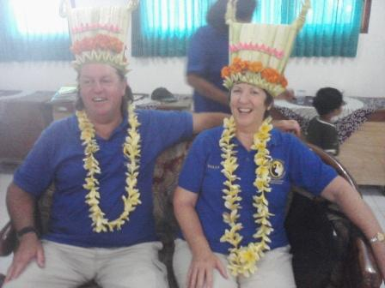

(English Club members, the teachers, Susan and Derek)

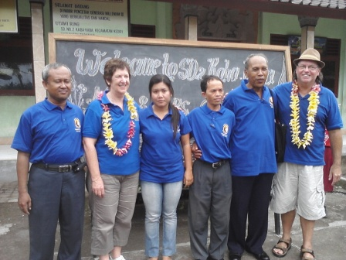 (Susan and Derek Cromb)
(Dadan, Susan, Trisna, Gayus, Alit and Derek)

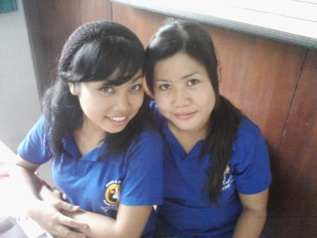

(Suci and Trisna on the photo above)
All students smiled when the graduation day on 10th June 2011. We passed the sixth graders to continue their study at Junior High School. We got small ceremony where all students participated with dance Balinese dance, singing, read then poem and many things did.
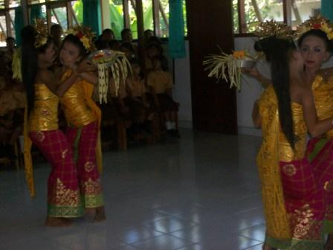Here are some pictures when we celebrate the graduation day.
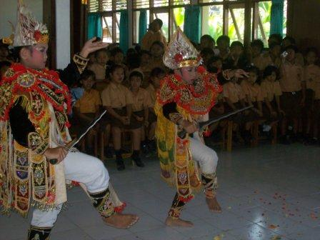

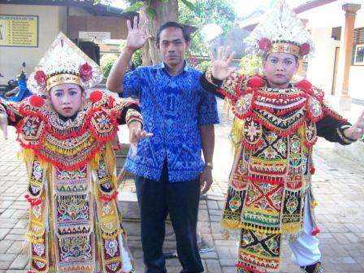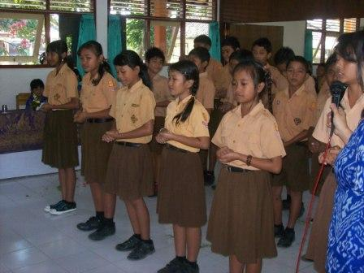

On June 8th, 2011, All students and teachers went to some tourism object as Annual Activity to celebrate the graduation day.
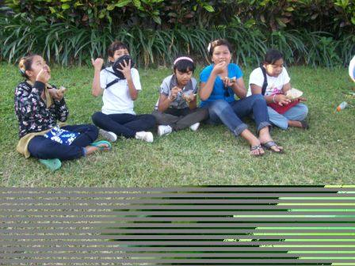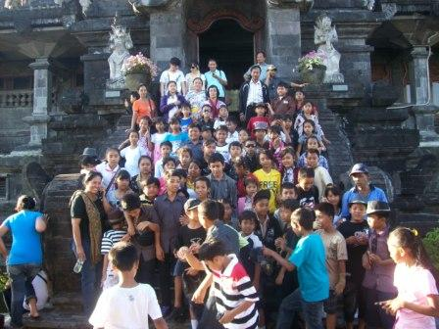

Visiting from Australia… Deane Campagnolo and Family
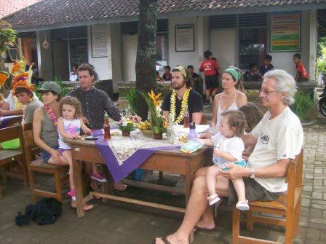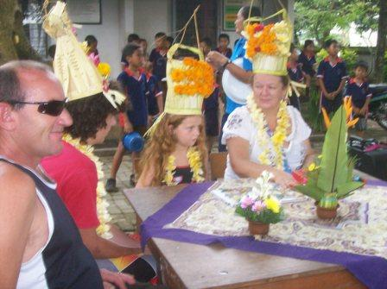

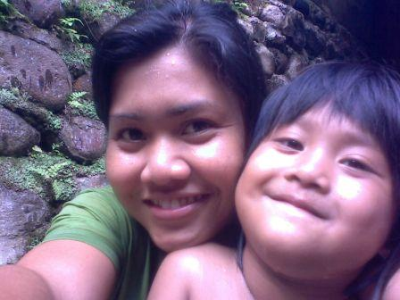
Trisna and Jessy

