VISIT TO PERTH, AUSTRALIA

Dear AAS Committee : Susan & Derek Cromb, Sherryn & Vic Reid, Sue & David Elliott and other AAS Committee members.
AAS Committee in WA invited me and arranged my visit to Perth recently. I realized that it was hard to collect such a lot of money, but you all worked hard in getting such a lot of funds. By doing fundraising concert at Derek & Susan's house, having a stall at the Mt. Hawthorn P.S and other efforts finally you could collect money enough for my travel requirements: passport, airfares, travel and medical insurances, visa application, meals, transportation and something needed for the purposes. Everything was financially organized by the AAS in WA.
Unlimited thanks to AAS Committee and to Donators, because of you, your generosity I could visit and see a part of Western Australia. I was really happy my dream for visiting WA became true and could see closely how schools in Western Australia are.
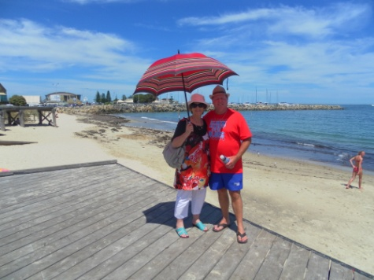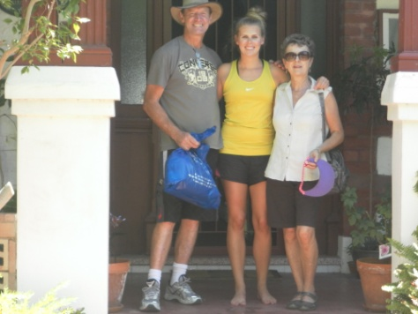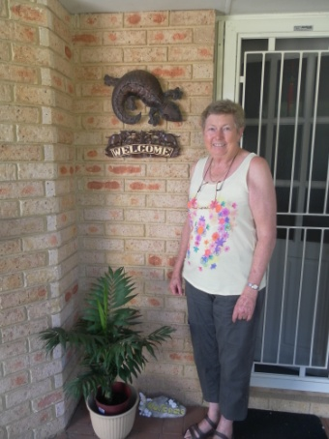
Susan and Derek Cromb David,Sharon and Sue Elliott Sherryn Reid
Dear my host families ( Susan & Derek Cromb, Sherryn & Vic Reid, Sue & David Elliott, Jane & Fred Morgan, Raja Pitts & Family, Lyn& Gary Tapper, Erlina Indrayani & John Bass).
When I was in WA I didn't stay in a hotel but I stayed with Australian families. One or two days stayed with one family and the other days with different families. Everything was provided by my host families. I felt I liked a part of their family. They fed me well. They sometimes took me out for dinner, for sightseeing and other activities. Now I know some interesting places in WA and Australian life style. My special thanks to all my host families, you had taken care of me. I was fine and I could do my daily activities.
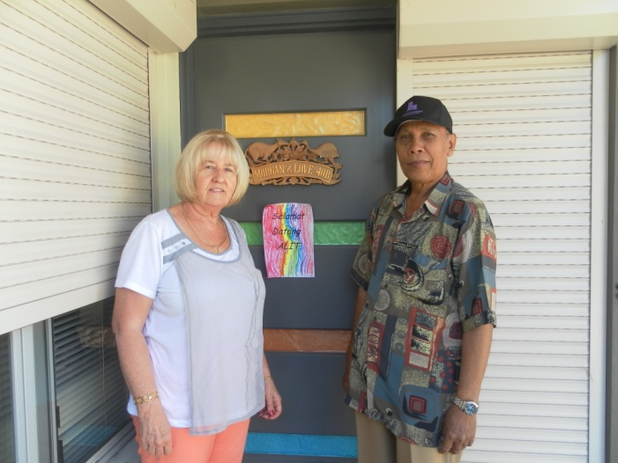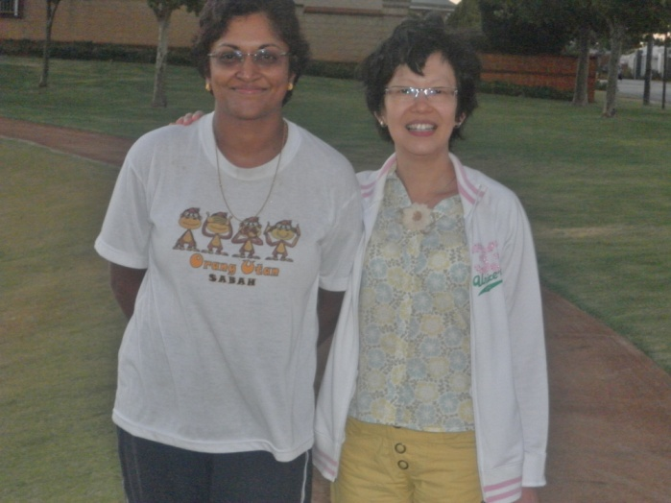
Jane Morgan and Alit Raj Pitts and Juli
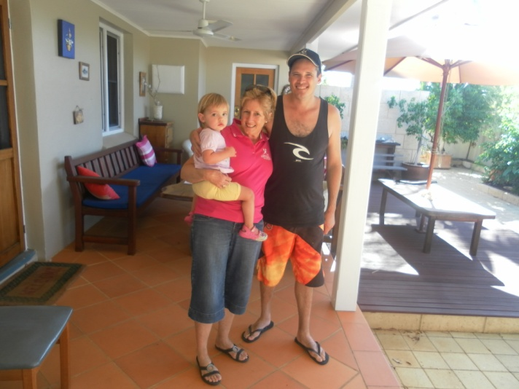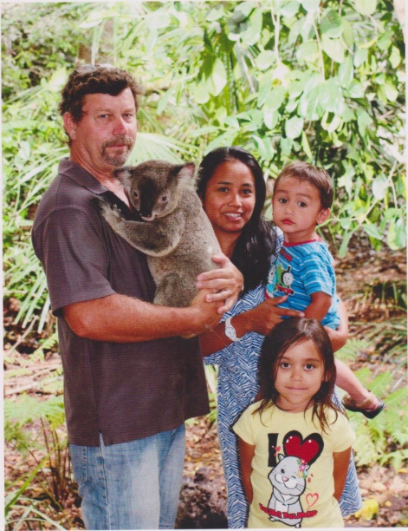
Lyn Tapper John Bass, Erlina, Malini and Clifton
Dear Sister Schools, school principals, teachers and students,
Thanks for the wonderful welcomed you extended to me on my recent visit to your schools.
During my stay in WA I had opportunity to visit some schools in Perth: Landsdale P.S, Morley P.S, Bletchley Park P.S and some others in Geraldton : John Willcock College, Geraldton P.S, Bluff Point P.S, Waggrakine P.S, Allendale P.S, and Mt.Tarcoola P.S.
I visited schools that has the Indonesian classes . I dressed some students with the Balinese Costumes. Students were interested in wearing them. Students asked me many questions about schools in Bali, about the school uniforms, language studied in Bali schools, what do you have for meals, why the teeth file, transportation and many others.
What the differences?
I found that schools in Western Australia have better school facilities, the school buildings are big, large school yards complete with sport utensils, so students feel free to move. Every school has a library, music room, Art room, school hall, the school canteen, etc.
Students in one class not more than 20 students. Classrooms activities are characterised with lots of interactive and communicative activities. Students are able to practise. Various group discussions and communicative games are specially designed to facilitate students to use Indonesian. Not all schools in WA choose Indonesian as Language Other Than English. There are computers in every class.
Students not just study in their classrooms, but also outside their classrooms. Students enjoy this so much as they can feel the fresh air. The classes, which run from Monday to Friday, normally start at eight in the morning and finish at three o'clock in the afternoon. Students have to bring their lunch or they can buy it at the school canteen. Some students go to school by school bus, some go to school with their parents, some go to school by bicycles.
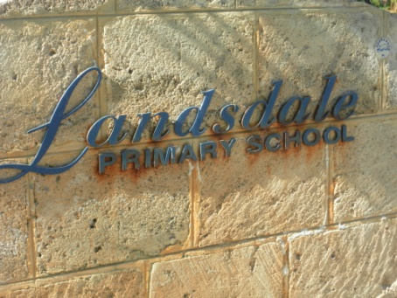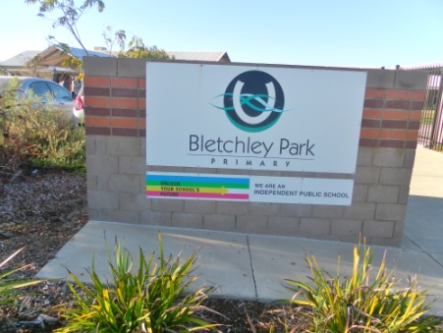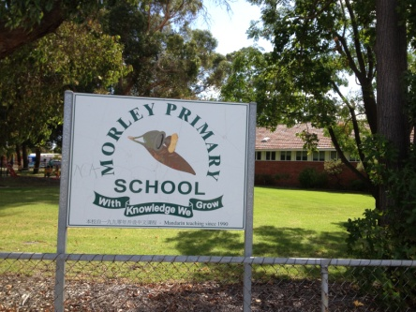
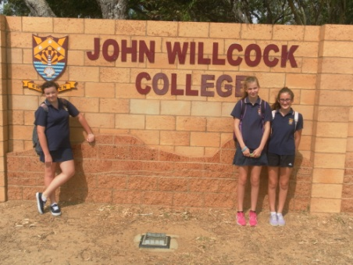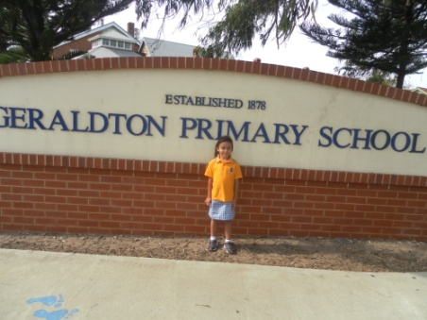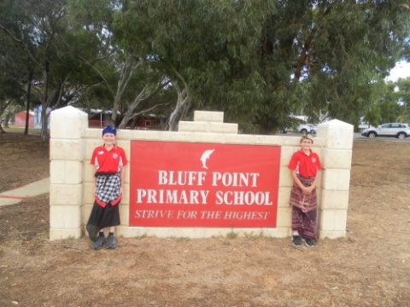
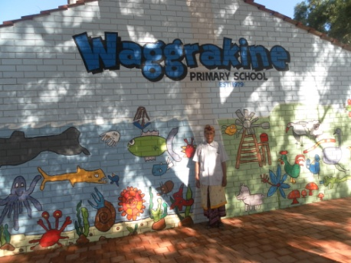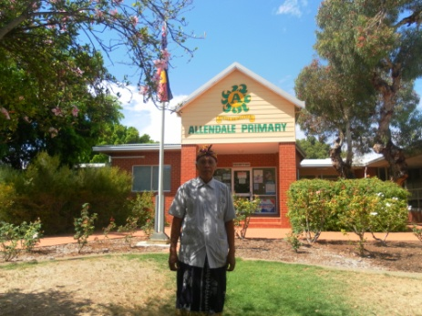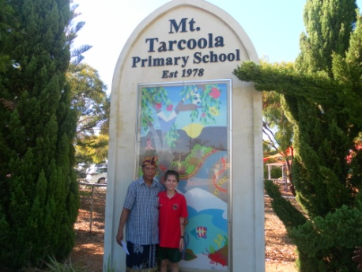

What lessons that I got from my visit to WA?
1.The different ways of teaching and explaining things made it interesting and fun to learn.
2. I found the Indonesian lesson at schools in WA really both for learning the language (Bahasa Indonesia) and Culture of Indonesian.
3 By living with Australian I could feel directly tradition and their life style.
4. Many others.
Finally, in this good opportunity I would say thanks for your hospitality, for your help and for everything from the beginning till the end, from my departure till my arrival or returned home safely. Well, no one is perfect in this world. Do please forgive me if there something that I had done intentionally or unintentionally that made you feel unhappy.

