A Visit To Sister School In BALI

We (myself, my husband Nathan and son Aidan from Aveley Primary School) were invited to visit SD4 Kaba Kaba School in Bali while on holiday.
Ibu Yang (the Indonesian teacher at Aveley Primary) made contact with Alit (the English teacher at SD4 Kaba Kaba) in the hope that we could visit at a suitable time. Alit was very pleased to arrange a visit on a Saturday morning (the students go to school 6 days a week!!!) when the students were not completing exams.

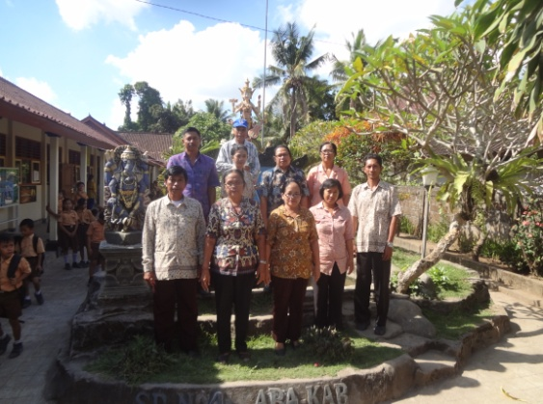
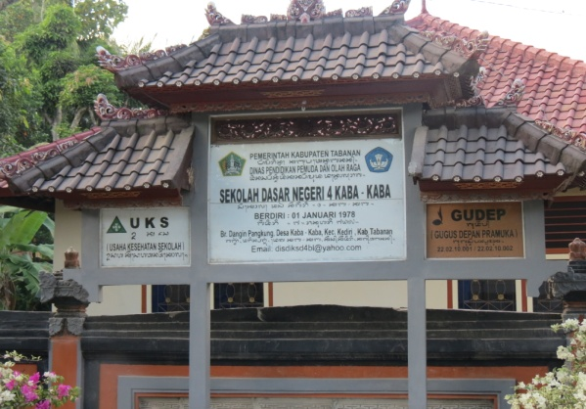

We drove for about an hour from Kuta to a small community. When we arrived, the whole school including students, teachers and the Principal were standing to greet us with a gorgeous handmade frangipani necklace each. The students were so excited. Aidan was introduced to a young boy named Yudi who spoke English very well. Yudi then started showing us around the school. Nathan took photos that everybody wanted to be in! Many of the senior students were eager to practice their English with a real English speaking person and they did a fantastic job. The classrooms are very neat with small wooden desks (they do not have puzzles, games etc to play with).
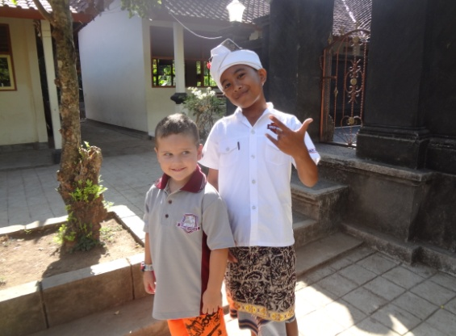
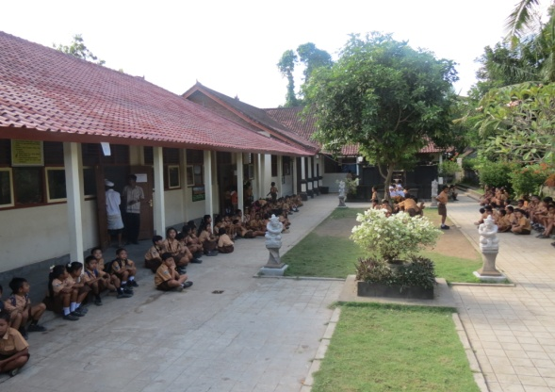
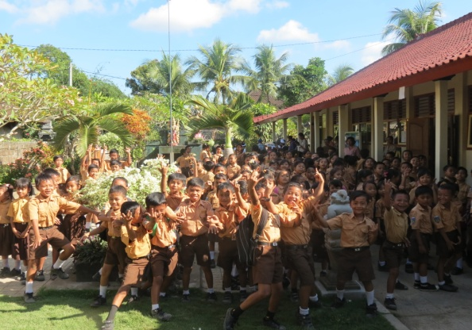
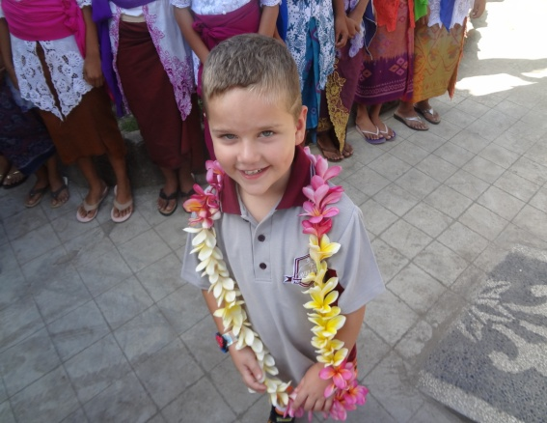
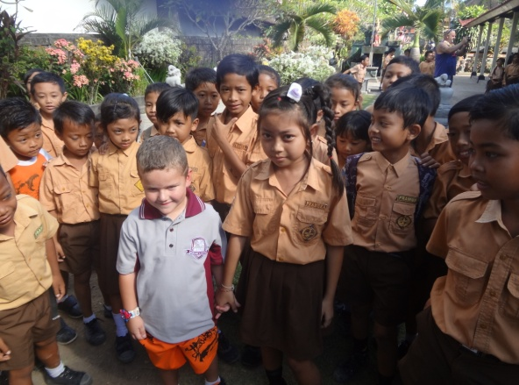

After a tour of the small and beautiful school ground and classrooms we were invited to meet with the Principal and teachers for morning tea. We learnt that there is no running water in the school. This is a main concern for the welfare of the students. There are also only two old computers for staff to use so the students are not able to use them for studies.

We made a donation to the school and presented the Principal with a Steve Parish book about Western Australia. We signed the visitor book, promising to return when we could. Alit made it very clear that visitors from Aveley Primary School are most welcome. The students are looking forward to trying out their English skills on anyone who has time to get there.

Written by: Samantha McLaren
Aveley Primary School

