TESOL Course in Milner International College of English

I would like to express my gratitude to Mr. Milner and all Adopt A School of Western Australian members for giving me opportunity to attend TESOL (refers to Teaching English to speakers of other languages) course in Milner International College of English. I attended TESOL course for five weeks starting from 5th February to 9th March. Then one week working with children in Belmont City College and Cecil Andrews High School.
Joining TESOL course gave me a great experience because as it was a great chance to learn new things about teaching an ESL classroom. It was about gaining comprehensive knowledge of teaching techniques and strategies that were related to teaching process. I learned about best practices and teaching methods that were specifically designed for working with non-English speakers. Thus it was about sharpening skills related to the task of listening, reading, speaking and writing. It further covers the lesson plans, classroom management and other techniques applicable at all levels of language learning for all ages of students-adults as well as young learners.
There were twelve students all together in my TESOL class. They came from different countries, such as; Japan, Korea, Brazil, Taiwan, Columbia, Portugal, Mauritius and Bali, Indonesia of course. Besides learning about TESOL, we also learned about each other culture especially about education. It was interesting to know about cultures of different countries which could give us a broader insight into other cultures.We felt very lucky that we have a great teacher, Felicity. She is a professional teacher who trained us very well in TESOL course. She provided us with useful activities to train us in teaching students, and we carried out practice teaching every week. It was very useful for us, we learned the theory then practiced it.
One week working with children both in Belmont City College and Cecil Andrews High School gave me great experiences. I did classroom observation and also helped some students who had learning difficulties. Therefore classroom observation presented an opportunity to see real-life teachers in real-life teaching situations. Through class observation, I gained lots of benefits, such as (1) observing new techniques, strategies, ideas and resources, (2) observing student reactions from a different perspective, (3) helping us create a professional learning community with the best interests of the students in mind.

Written by
Desak Made Rukmini
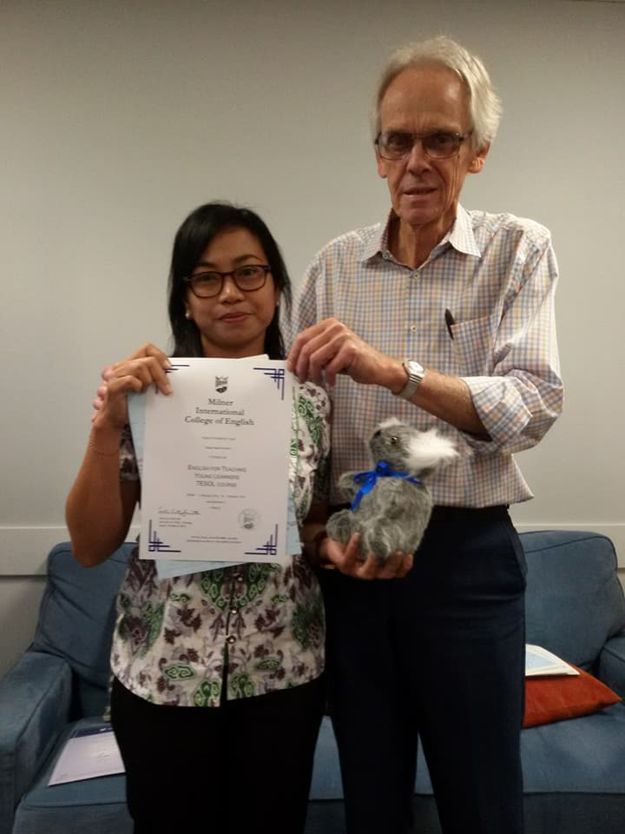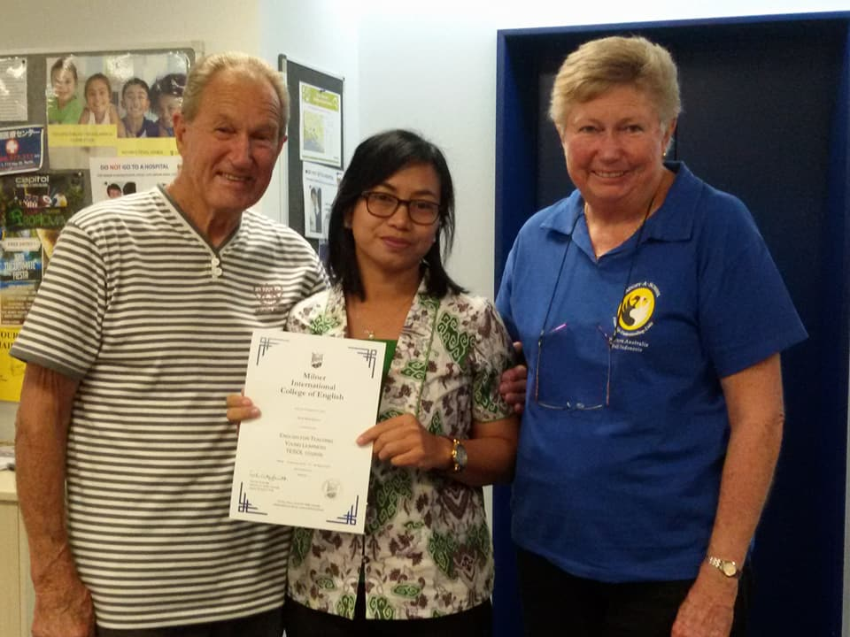
Graduation day with Mr. Milner Graduation day with Vic and Sherryn Reid

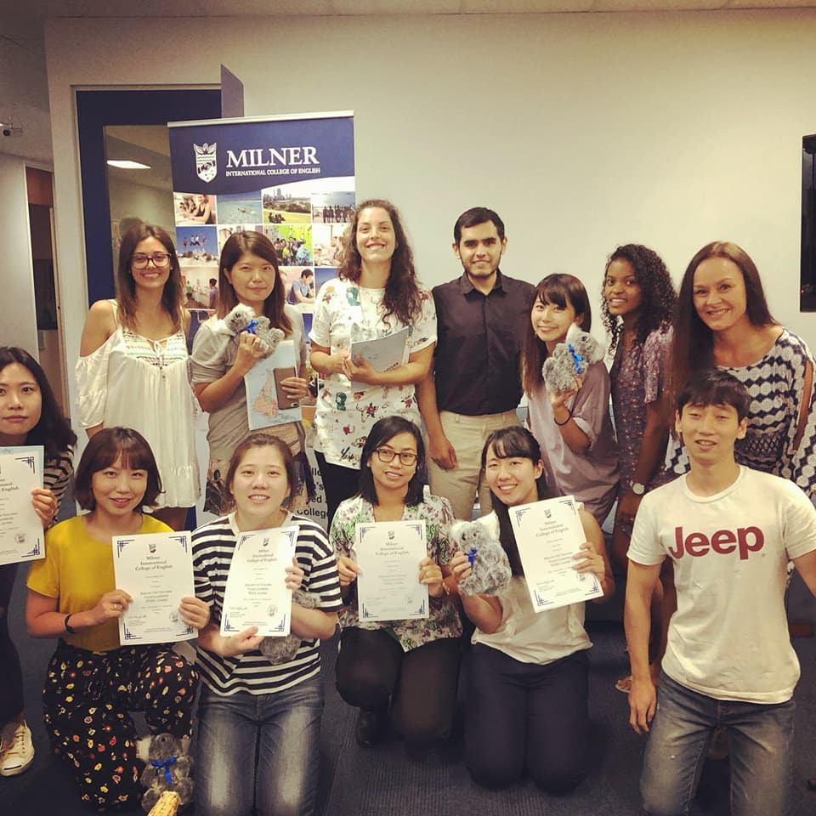
Graduation day with my classmates

