Yay! We get to actually meet some more of our sponsors.
Over the years, being sponsorship coordinator, I meet many people and sponsors via internet or phone but have never seen face to face. Vic and I recently travelled to New Zealand, via Melbourne where we had a week’s stay. This was an opportunity to have a couple of get-togethers and actually meet the sponsors.

Thursday night dinner at the Rosstown Hotel in Carnegie gave us an opportunity to finally meet in person, Jess Traher, who was a previous newsletter editor for AAS, is currently a sponsor and also Lou and Maria Papile and Con and Rosa Antonello. We travelled from Melbourne and return by train and had a most enjoyable dinner and evening chatting like old friends. Thank you all so much for a lovely evening. It was wonderful to meet and I do hope there will be further opportunities.
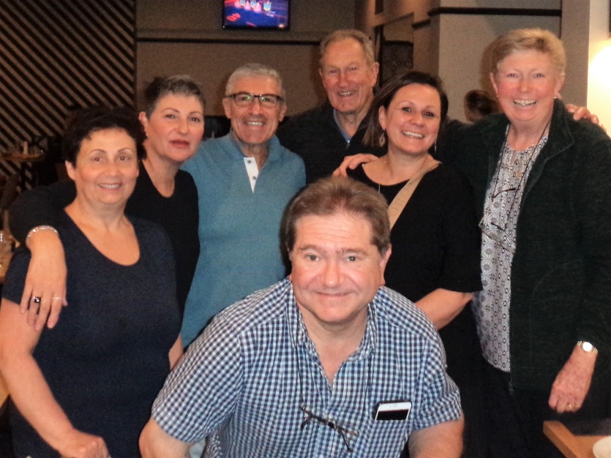
Con in front, then L-R Rosa, Maria, Lou, Vic, Jessica and myself

On Sunday we enjoyed a bus ride through the scenic countryside to Leongatha in the Gippsland area. We were met by Lyn and Gary Yeomans who you may know are great supporters of AAS, have assisted with the Volcano and Earthquake appeals in recent times in Bali and Lombok. We went to their lovely property and had a cuppa and caught up a bit. Then we were off to the Leongatha RSL to meet the local sponsors and have lunch. Some we had met in Bali but it was delightful to meet Great Aunty Nancye, about who we have heard so much. We had a pretty nice meal there and there was a lot of fun and laughter and sharing of stories.

After lunch Gary took us for a drive to see the beaches and other areas of interest. You may also remember the fantastic effort by a young man, Eric Grattan, a few years ago when he grew his hair and a beard for a year and was sponsored by many people. One of his sponsored students will be graduating from University next June – and there are others. Eric and his lovely lady Bianca are now building their own home nearby. Eric is Lyn and Gary’s son. We visited and only stopped him working briefly. They are doing the physical work themselves and you can see their efforts already coming to fruition.

In the evening we returned to Melbourne on the bus and enjoyed the countryside once again.

At the Leongatha RSL
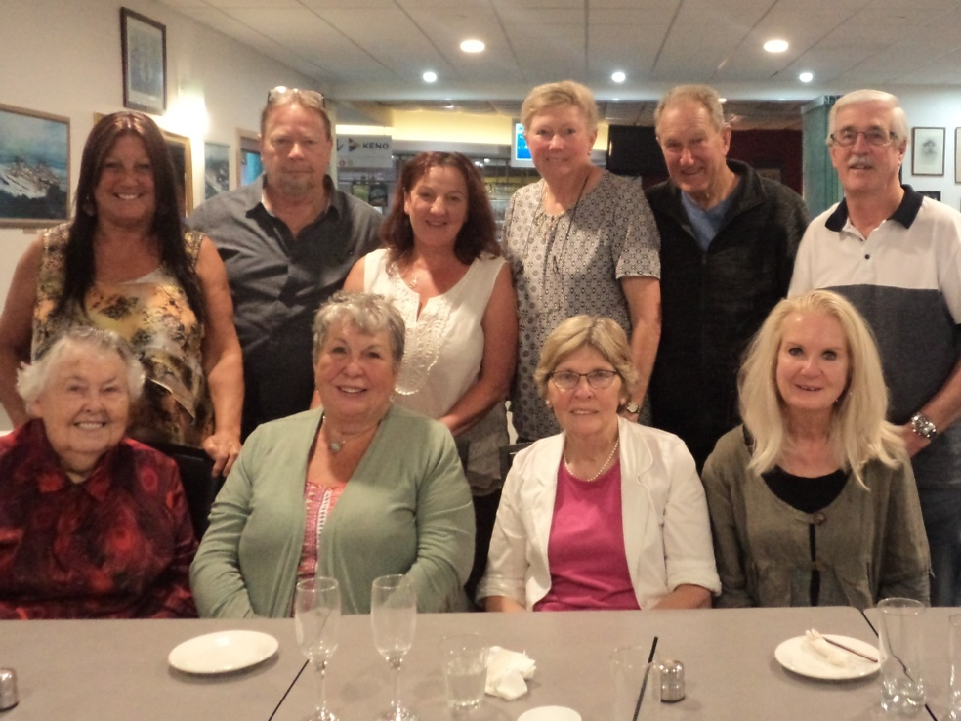
Front L-R, Great Aunt Nancye Hollings, Helen Taylor, Pat Fell, Lee Ann Mitchell.
Rear – Lyn and Gary Yeomans, Carol Hanratty, Sherryn and Vic Reid, Peter Fell.

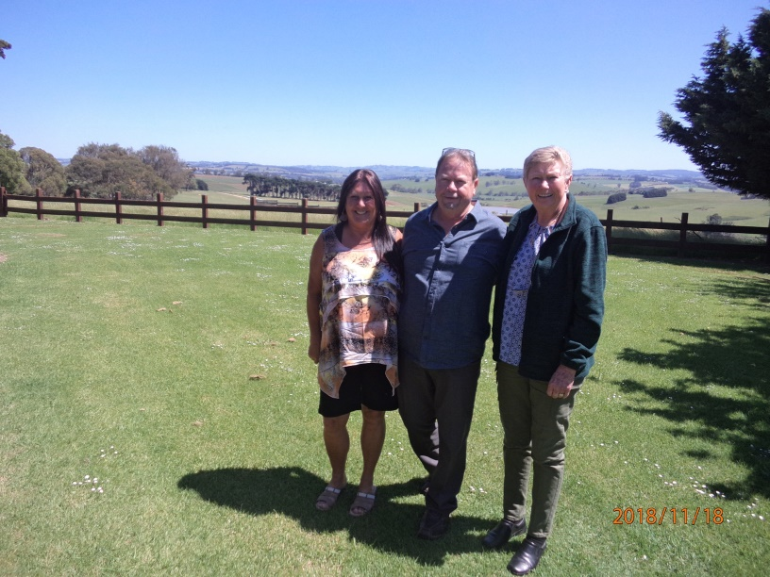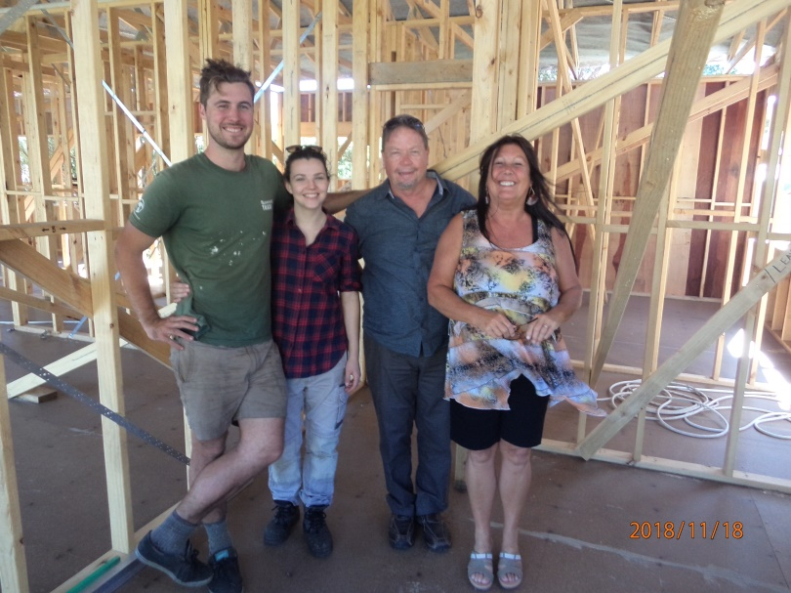
Lyn and Gary’s view from the front of their house Eric, Bianca, Lyn and Gary in the house under construction

Thank you all for a wonderful copuple of visits. It does make a difference when we can put a name to a face and have actually met you all. Thank you all for your support to AAS. It really is changing lives for children and families in Bali.

Sherryn Reid, December 2018.

