ISSUE 26 SEPTEMBER 2019

A note from the AAS President - Sheila Hay
This year seems to have slipped by very quickly. Our committee has had a few changes. Thank you to the new committee members for the work you have already demonstrated that is bringing results.
We are looking forward to seeing some more of the sister schools represented at the AGM on 19th October, 4-6pm at 228a Kooyong Rd, Kewdale. There is plenty of parking opposite. Phone 9355.5505 if lost. The position of Membership Records Officer will be vacant if anyone would like to nominate for the position. Thanks to Kathy Warren for all she has done in a short time.
The ongoing issue with the Bali bank account has been finalized and is addressed in this newsletter. Thanks to Dewi, Yuni, Eka and Sri for the assistance in Bali to ensure all the relevant information was provided to enable the new account to be opened.
Many of our students have recently graduated and we wish them all the best for the future.
Thanks to all our supporters and members. Without you, none of our projects would come to fruition.

Sister School St. Simon Peter Catholic Primary School and SD3 Mengwi – by Jamie Lamont
St. Simon Peter Catholic Primary School at Ocean Reef established a sister school relationship in Bali over the last 12 months. Our sister school is called SD2 Mengwi and is situated about one-hour North of Kuta and has approximately 170 students.
We connected with this school through AAS, particularly after meeting with Susan Cromb and talking about some logistical issues. Our school is committed to have a longterm relationship with SD 2 Mengwi and last April our school leadership visited our new friends in Bali to sign off on a Memorandum of Understanding (MOU) between the two schools (written in both languages).
Our Year 5 students have started communicating through a pen pal relationship and we are planning a school visit in the October school holidays (hoping for about 10 families to visit the sister school). Both schools are trying to support each through helping with teaching resources and we have a fundraising committee at our school that raises funds. Our aim medium to long term is to have some students/teachers from Bali visit us in Australia and spend some time at our spend some time at our school and in our community.

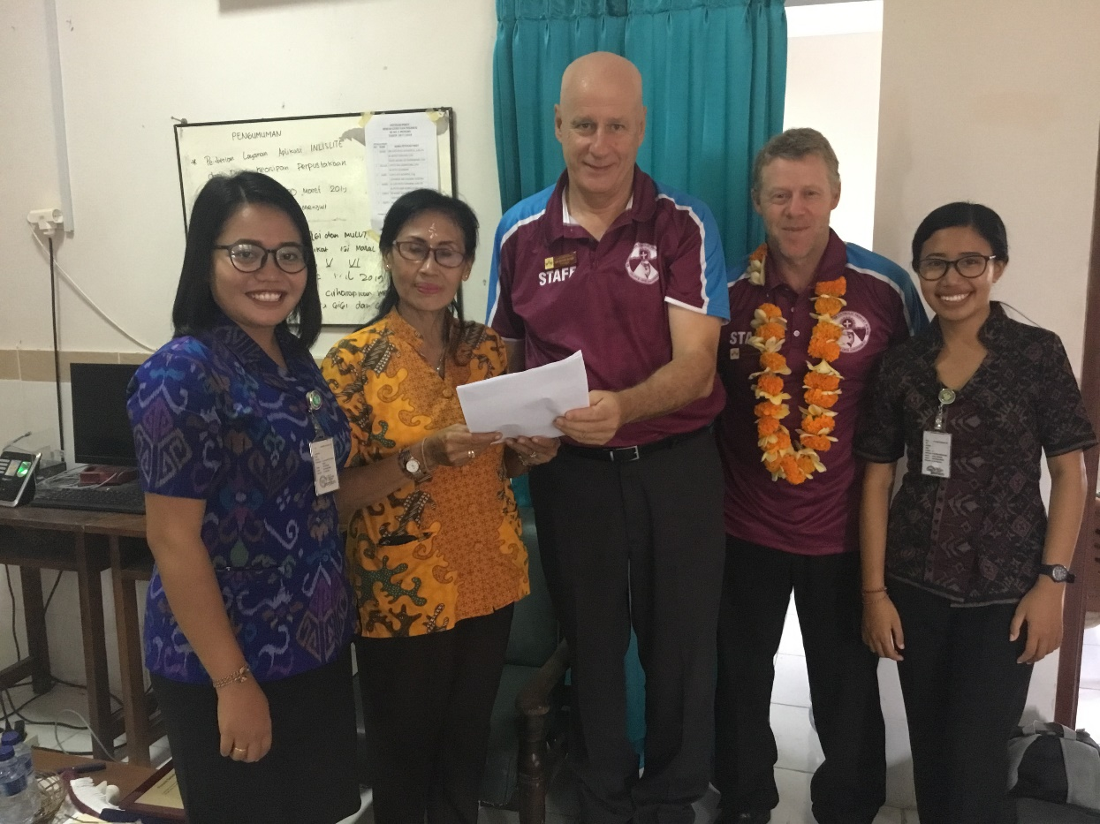
St. Simon Peter CPS and SD2 Mengwi signed MOU, Bali 2019

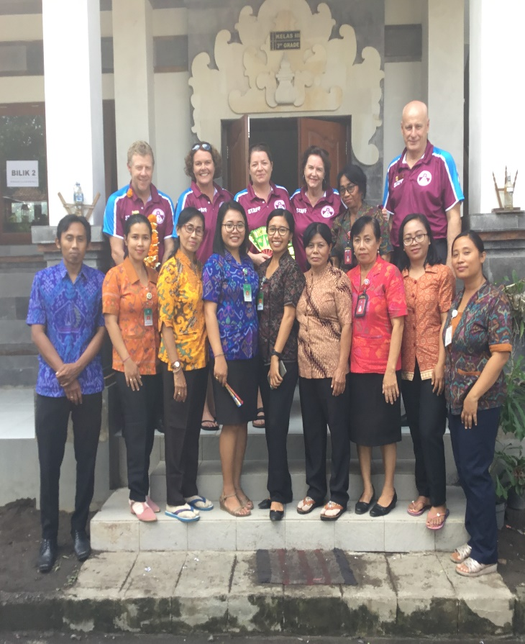
St. Simon Peter CPS in Bali, April 2019

Again, another fund raising from Iona Presentation College
Chloe Hoad, a year 5 student at Iona Presentation College Junior School has successfully raised funds totalling to AUD $320 for SDN4 Banyuasri in Singaraja with the help of her family members. SDN4 Banyuasri has been the sister school to Iona Presentation College Junior School since 2016.
She diligently saved her pocket money and earned extra funds by doing household chores over a period of three months. Chloe also held a bake sale to raise additional funds for SDN4, selling treats outside the garage of her home.
She was inspired to assist the students of SDN4 Banyuasri after hearing of the initiatives of a few individual senior students in the Junior School who raised funds for SDN4 in 2018. She came up with a few ideas to raise funds and with her mother, Kate achieved this amazing feat.
“I hope that these funds will assist the students at SDN4 to reach their educational targets. I am happy to be able to help them”, Chloe shares. She enjoys traveling to Bali and hopes that she will be able to visit the students at SDN4 Banyuasri in the near future.
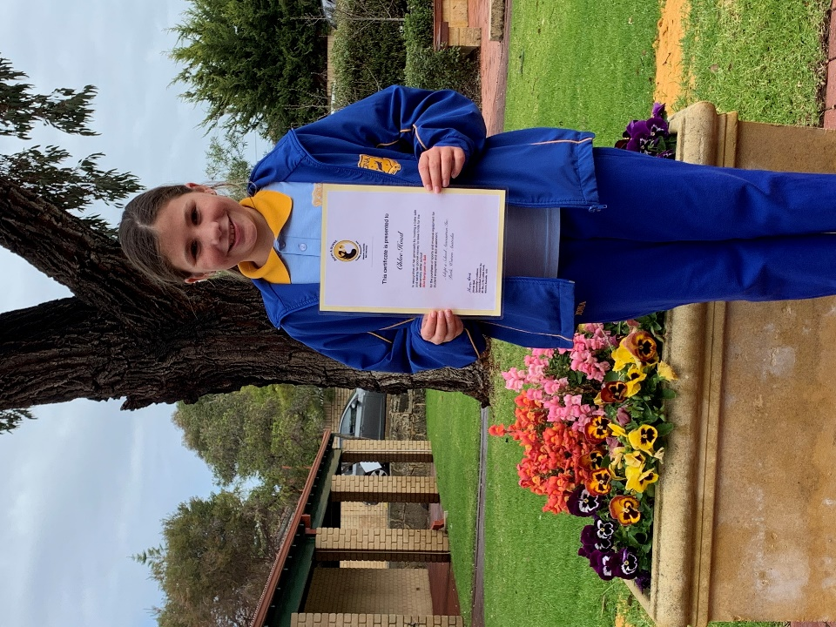
Chloe Hoad with her certificate of acknowledgement from AAS.

AdoptASchool acknowledges Chloe’s great efforts and have presented her with
a certificate of acknowledgement.
Thank you very much Chloe! (Terima Kasih banyak Georgie!)
English Teacher at SMPN2, Kuta, recipient of an AAS Scholarship and graduate of TESOL at Milner International College of English, Perth – Desak Rukmini

Huge congratulations Desak from all of us here at AdoptASchool. You were a very deserving finalist.

First, I would like to express my gratitude to the almighty God for his blessing that I could come to national competition level. This level is dreamt by all teachers in Indonesia. It is the competition of outstanding teachers. It was a long journey until I could go to Jakarta to join the competition.
Lots of work needed to be done to prepare for the competition. There were participation in workshops and seminars, writing classroom action research and other reports to demonstrate the improvement in my knowledge. The Outstanding Teacher’s Competition was started from regency level.
It was in February that my headmaster asked me to join the teacher’s competition for regency level. At first there were three steps I needed to pass. They were portfolio, written test, and interview test. There were about 30 teachers of junior high schools around Badung competing. The next tests were when I was chosen to be one of the top five, they were classroom action research presentation and teaching observation. After passing those hard tests, it was announced on April 29th that I had achieved the first place.
The competition then continued to the next level, province level. In May, I competed with eight teachers who are from different regency’s around Bali, such as Bangli, Klungkung, Denpasar, Karangasem, Gianyar, Buleleng, Negara and Jembrana. They are the best teachers from their regency. The next month, it was announced that I had again won the first place. It was unbelievable I competed with eight best Bali teachers.
The final outstanding teacher’s competition was national level in Jakarta. It was an unforgetful memory that I could join the competition that was dreamt by all teachers in Indonesia. Meeting with 33 other best teachers coming from provinces around Indonesia was a great experience. We shared and learned many things together. Though I only became a “finalist” on that competition, I was so happy that I learned lots of things from other friends.
One thing was that becoming a teacher, we just need to learn and improve ourselves, long life education, updating ourselves in order to be able to share our knowledge to students that the students will be able to apply their skills in real life.
I am so proud to be part of them with the best teachers from every province around Indonesia. Thank you to everyone who has assisted me on this amazing journey.
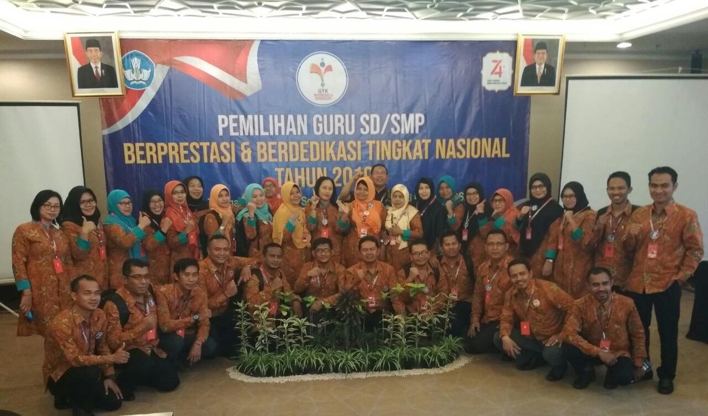
Desak with other teachers at the national level competition in Jakarta

McClellan family visited SDN 2 Pegadungan Buleleng – By Dwi
We are very blessed because the McClellan family visited our school, SDN 2 Pegadungan Buleleng, Bali on 12th July 2019. They were welcomed by welcoming dance named “Puspanjali Dance” which had been danced by Dwi when she was invited to visit Dalkeith School 2 years ago. Off course McClellan family give us big effect because they motivate our students to learn English very well. They try to make conversation with our students especially their sponsor children, Widia and Satria in the last session. They gave us some English book resources to improve our teaching and learning process, some cute stickers to motivate our students to finish their English assessment and so on.
The McClellan family and our students tried to communicate by using the English play game “asking and answering”. Our students, SDN 2 Pegadungan asked the McClellan family some questions and they tried to answer those questions. After that, one of my students tried to repeat again the McClellan family’s answer. It was beneficial because it indirectly taught them how to respond and repeat what the others say.
Our students were very happy to meet them, not only my students in SDN 2 Pegadungan but our former students who have continued to Junior and Senior High School. Students in Junior and Senior High School are more fluent when making conversation with them. That also became their challenge for them to speak English more deeply. Besides that, some of my students have desire to be guide or have wish to continue their study abroad if they get scholarship to give them other experiences.
Once again, we are thanking to McClellan Family because they spare their time to visit our school.
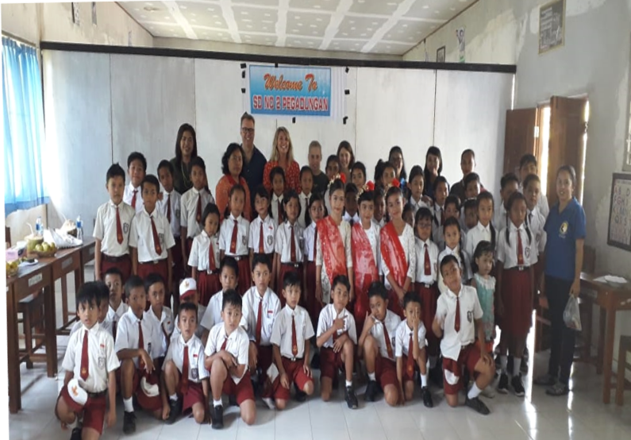
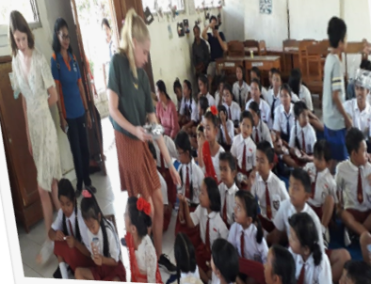

Share a post from Global Village Foundation, Bali about Putu Risma
Putu is the young boy from near Singaraja born without hands.
He is such a bright positive little guy, and despite his disability, he is determined to lead a full and happy life. He has been learning to read and write during his first years at Kindy school, and a few months ago was presented with a refurbished laptop computer by the Global Village Foundation, dodnated by AdoptASchool, to introduce him to technology at an early age. We were also privileged to be able to present him with a specially adapted bicycle just recently.
He will face many challenges as he grows up. He certainly has the right attitude to confront them, and he has a very wonderful supportive family. To give him the very best chance of a full & happy life, he also wants, and will need, the best education possible. To this end, Global Village Foundation sought a sponsor to help fund his education.
We are so very pleased to announce that through our very good friends and Partners at the Perth based Adopt A School charity, we have secured a scholarship for young Putu, that will pay for all his schooling costs for the next 12 years, taking him all the way up to University age.
As a result, he was able to begin Year 1 at primary school last week all dressed in his brand-new school uniform paid for from scholarship funds. He had been at school for only a week and was already very actively involved in the school concert of Balinese dance put on especially for the parents of the new Year 1 students.
The Global Village Foundation will disburse the funds each year on behalf of Adopt A School for Putu’s schooling, and educational needs. We will be following young Putu's progress closely, and be on call to support him, as he confronts whatever obstacles may lay in his path.
Alongside the massive Thank you we say to Adopt A School, we also say a huge thank you to 'D' team at The Police Operations Centre, of the WA State Police, based in Midland who have also joined with us to support & sponsor the additional educational tools that young Putu will need as he goes through school..
From Putu, his parents & Family, and from the Global Village team to Adopt A School, and to 'D' team at The Police Operations Centre in Midland we say SUKSMA, TERIMA KASIH BANYAK, THANK YOU SO VERY MUCH.
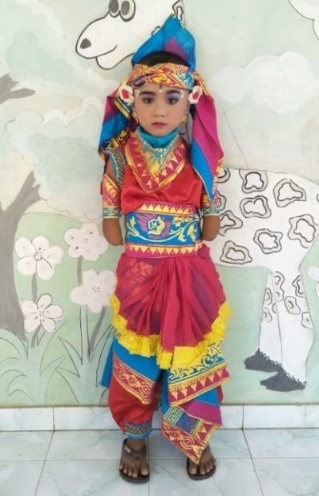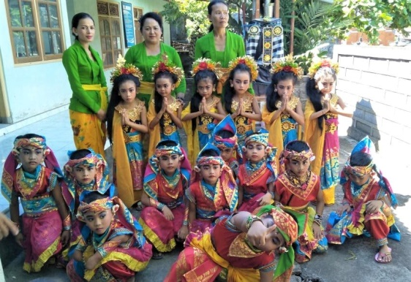
First day of year 1 Dance costume Putu with his dance troupe

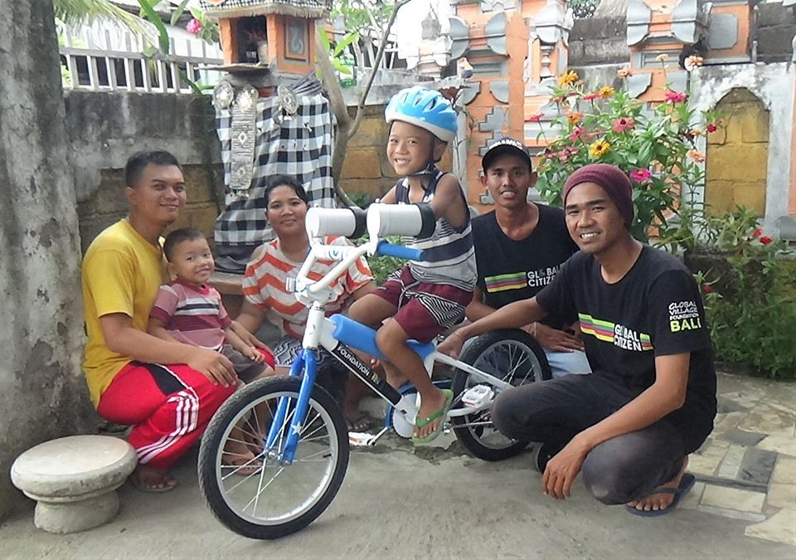
Dad, brother Kadek (3), Mum, Putu Rizma, Rudi and Kadek from Global Village Foundation
Thanks to David Barnsley of Shell, who modified the bike for Putu and Dave from Ride, Repair, Retreat, the Kalamunda bike shop who assisted.
AAS Bali Bank Account.
When Adoptaschool Association Inc. started in 2002 a bank account was opened in Bali to facilitate the transfer of funds from Australia. Over recent years a number of regulatory changes have been introduced in Bali and it became necessary for us to restructure our affairs over there and as part of that process a new bank account was required to be opened. Unfortunately, many of these regulatory changes were introduced to prevent the use of Yayasan’s (Indonesian Charity) being caught up in and used to commit fraud and scams. As a result, requirements have been updated, tightened and there are strict procedures to be followed for Yayasan re-registration, which is with what we have had to comply. New tax certificate, Social Department requirements, a registered office in Bali with a sign outside showing the positions and name of the committee members and many other little things have had to be accomplished. Despite commencing in early 2019, it became long, drawn out process as after submitting papers to the relevant departments there were sometimes weeks of delays waiting for a response. Of course, until the registration process was complete, a new bank account was unable to be opened.
In the meantime, some of our schools here had deposited funds for sister school projects and we were unable to transfer the funds to Bali. This week on 25th September, our new account was finally opened, funds were transferred to Bali on 26th and we should be back to normal once Sri our Bali Treasurer is able to transfer funds to all the schools.
Thank you to all the schools and sponsors here, who have been supportive and patient. It has been a long, frustrating haul but one which will continue to give AAS the credibility that is so important to our organisation.
Sherryn Reid.
Congratulations.
Congratulations to Oka Darmaja our Benoa and Jimbaran coordinator and his wife and family on the arrival of a son, I Gede Vikananda Arjawa on 20th August, 2019. Vikan means smart, Nanda is child and Arjawa is polite Balinese language meaning honest and lucky. Oka and his wife hope that their son will grow up to be smart, honest, lucky and successful. He will be called Vik as it is a good name to hear.
Also congratulations for our Pecatu coordinator, Anief Arzuani, who this week has been transferred to SD6 Tuban (South Kuta) to be nearer to her home and family consisting of husband, three children and another expected early next year.
Congratulations to the AAS Secretary, Aly Bannister.
It is such a privilege to be part of the ‘Adopt A School’ family. I officially became Secretary earlier this year. Now, as my capacity as Secretary, I can share some exciting news that happened to me personally and took place during September.
I started my new business as a Career Coach in May 2018 – Alison Bannister Career Coaching. Since that time, I have been able to help numerous people find Employment, assist with Job Interviews and Resume Writing. I also work with many Australian Defence Force Partners – supporting their career journey and assisting with their Employability skills training.
One of my business associates kindly nominated me for the ‘AusMumpreneur’ Awards. Which is a dynamic group of mothers who have all started their own businesses and are achieving some staggering results. I was honoured to have been selected as a finalist for the category of WA Business Excellence. Therefore, I flew to Melbourne to meet the judges face to face at the beginning of September and state my case.
The judges on the panels had a really tough job of selecting the winners. Especially from a group with around 27,000 women. However, my business was selected and was awarded Silver place for WA Business Excellence – which I am thrilled at.
In addition to this, my business was selected as a Finalist for the Prime Minister’s Veterans Awards – Supporting Spouse Employment. Which meant that I got flown to Canberra to dine with the Prime Minister, Mr Scott Morrison and meet all of the other finalists too.
Ultimately, it is my aim to create a greater awareness of the work that Adopt A School does and the huge effects it has on the beneficiaries of the charity.
I am truly grateful to be contribute in some way, and hope to be more successful in the coming years. So, I can contribute a great deal more financially and personally to the plight of the team.
Here is a snapshot of my trophies:
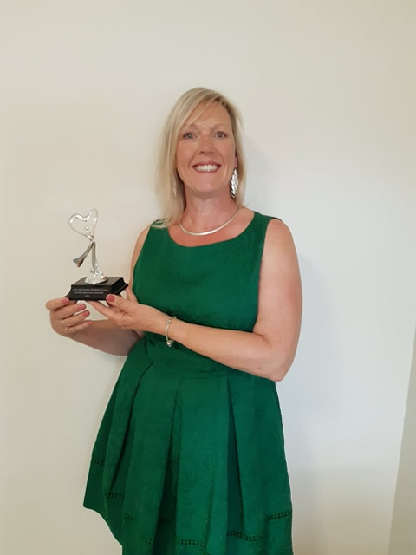
Keeping students in school.
Several of the villages in the north of Bali where it is very dry for many months of the year, have no potable water which results in someone from the family having to walk several kilometres each day to another village to bring drinking water home for the family. Often this responsibility is given to one of the children. We are finding that students need to leave school half way through their classes each day to enable them to walk and return before dark. Global Village Foundation in Lovina is endeavouring to place water filters in many of the houses to eliminate the need to travel to bring drinking water. This will enable the students to attend school for full days.
Purchasing, transporting, installing and maintaining the water filters cost $40 each. If you would like to support this project, funds can be deposited with AAS for transferring to Global Village Foundation. Please advise me by email of your deposit, it will be receipted by AAS and acknowledgement will be sent via email to you by Andy Bracey of Global Village Foundation.
Deposits to AAS - ANZ A/c - BSB 016-286 Account 4958-51244. Please confirm your deposit to: sherrynreid@hotmail. com. Thank you all in advance.

How water filter 2 bucket system works.
Dirty water is put into the top container in which the candle is placed. Water will drip through the candle and the fast flow hose connected to the candle into the bottom bucket. The Tulip Table Top filter will purify the water of bacteria, parasites and turbidity. The water will be stored in the bottom container making sure that the water will not re-contaminate. The water can be used for drinking via the tap in the lower bucket. MANUAL TABLE TOP For whom applicable Households: The Tulip Table Top filter is easily applicable for all members of a household. The water storage in the bottom container ensures that water is not re-contaminated. School classes: Tulip Table Top is ideal to realize safe drinking water at schools as part of a WASH strategy. Being able to drink safe water during the day will increase the concentration and attendance of children. Also, children can be strong advocates of safe water and hygiene at home when they learn this at school. Maintenance of the filter To protect the filter element against premature clogging when using dirty water, the filter element is covered with a washable pre-filter. After some time, the flow rate will reduce because of clogging of the filter element. When this occurs a small layer of the ceramic material of the filter element has to be removed by scrubbing the filter. This can be done easily by using a scrub pad, which is included with the filter. Pricing: One of the core values of BWN is ‘affordable’. Therefore we will always strive to work in the most cost-effective way. Considering one filter can clean up to 7,000 litre, the price per litre is between $ 0.002 and $ 0.005, depending on the distribution situation.
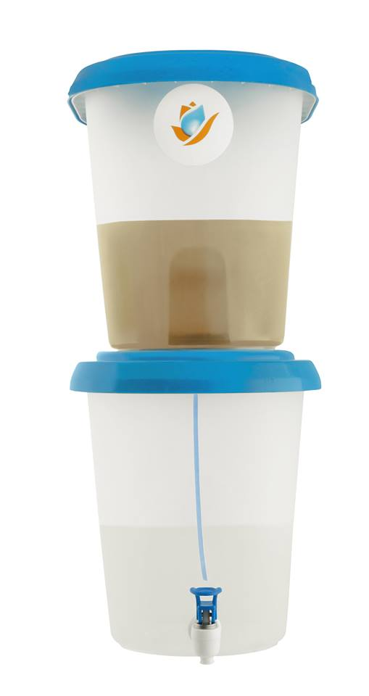
Our Supporters
Appreciation for support to AAS goes to:
- Consulate General of the Republic of Indonesia in Perth, WA - and staff for their continued support.
- Past Consul General of the Republic of Indonesia in Perth, WA - Mr. E.D. Syarief Syamsuri
- Milner’s International College of English, Warren Milner provides scholarships to Bali teachers.
- Metropolitan Omnibus Company, Bob Pearce. For bus hire rates phone 0418 337 302.
- Special thank you to AirAsia Indonesia for donations and assistance. It is very much appreciated.

How can I join?
Membership details are as follows:
Corporate Membership $100 minimum per annum
Private Membership $10 first year (includes certificate), $10 annual renewal
School Membership $30 per annum (Includes certificate)
All members receive AAS newsletters.
Committee
President Sheila Hay
Vice President Kim Bebbington
Minutes Secretary Aly Bannister
Treasurer Shane Scott
School Liaison Officer Amanda Anscombe
Membership Officer Vacant
Sponsorship Coordinator Sherryn Reid
IT Administrators Andrew Rowe
Wiki Coordinator Andrew Rowe
Editor Monika Simpson

Visit us on www.adoptaschool.org.au
Like us on Facebook AdoptASchool Australia

