AdoptASchool Association Inc,
PO Box 2190, Carlisle North, WA.
ABN 82 751 419811

20th September 2020

Greetings Sponsors and Sister Schools,

Vic and I have just been away to Kalgoorlie, in the Goldfields, for five days. We travelled on the Prospector train, a seven hour trip each way. We can thoroughly recommend the trip by train. The country is green, the crops are looking pretty good and wildflowers are abundant. Kalgoorlie is a very interesting gold mining town with lots to see in a few days. The Super Pit is amazing and well worth the cost of a tour. Vic was interested in trying to find information about his Dad who was there in his early years and enlisted in the army in Kalgoorlie for the first World War. That is an ongoing project.

Thank you to all the sponsors who have deposited funds to enable the Food Aid Programme to continue. A lot has happened in Bali in that few days we were away. Corona infections are accelerating and many of the villages are now infected. It is reported that a lot of people are recovering at home. In Denpasar, Yuni has distributed another 20 Food Aid parcels and Oka Darmaja another 30+. Oka has been assessing families in his school area in the South of Kuta and also in his home village in the North of Bali. Here are photos of some of the very needy recipients he visited in the North. A smaller parcel has been given to older couples and individuals as opposed to the family packs, which are for four to six people.

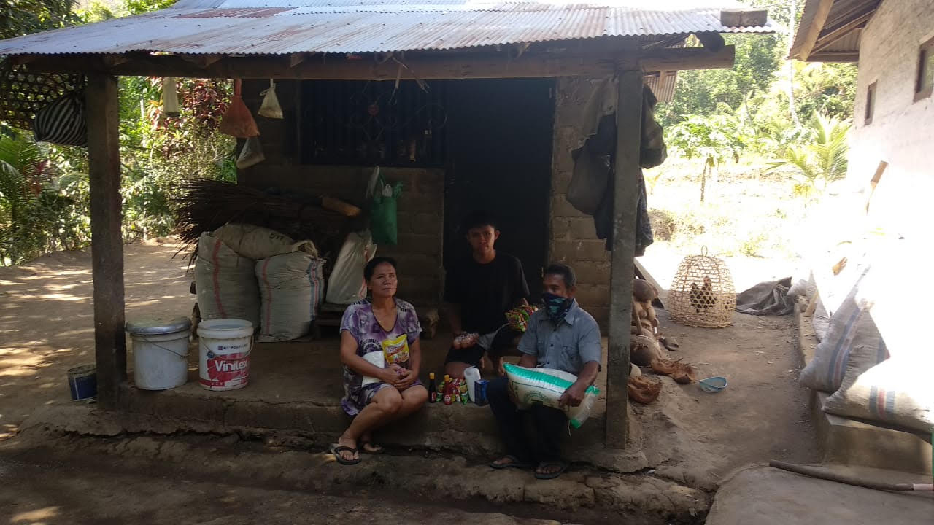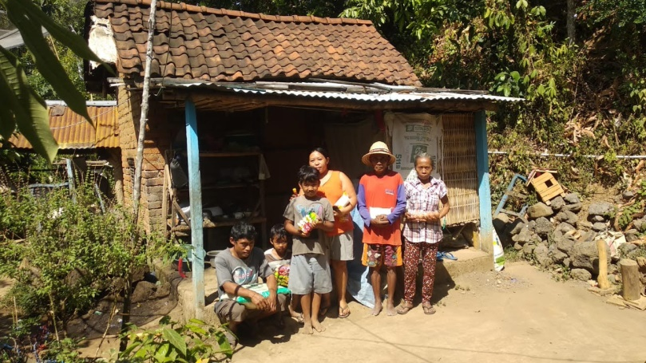

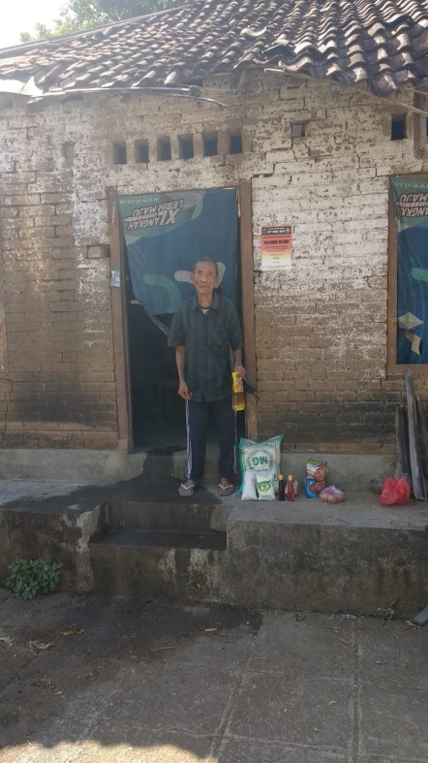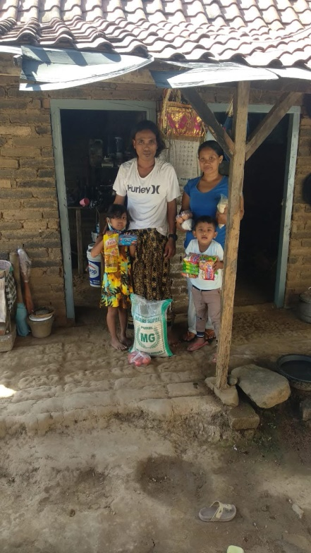
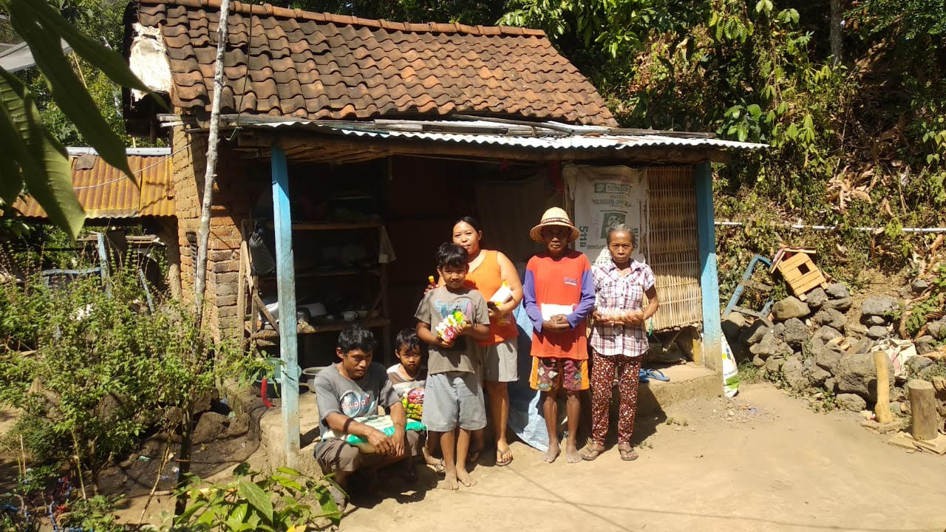
As you are probably aware, AAS works with Global Village Foundation in the North of Bali on occasions. Here in Australia, GVF sponsors are invited by Andy Bracey of GVF to deposit their support with AAS and we in turn transfer their funds regularly to GVF, Bali. Below is an article that appeared on the Global Village Facebook page this week.
“Global Village Foundation is with Oka Darmaja and 8 others.”
Sunday 13th September. The GVF team are contacted by our very good friend Oka from AdoptASchool Charity. Whilst out delivering Covid-19 Food Aid parcels in North Bali, he met a 79 year old former Gamelan musician in desperate need of a wheelchair.
Cared for by his wife and supported by their Grandson, Pak Ketut had been unable to walk for the past three years.
Oka’s timing was perfect. The Global Team were planning to be in that area of North Bali the very next day.
Despite the very difficult access, a new wheelchair was delivered the following day on motorcycles, by the Global Village team, along with a new water filter compliments of SPI, and a few kilos of extra rice to compliment the Food Parcel they had received the previous day from AdoptASchool.
A very happy and grateful Pak Ketut gave the team a short recital on his Gamelan instrument to express his gratitude.”

A video clip of the route the motor cycles took, carrying the boxes of wheelchair to be assembled and the visit to Pak Ketut is available on the GVF Facebook Page.

Again I can only thank all of our supporters for their donations. We will continue to do what we can. Our AAS coordinators in Bali are constantly monitoring the sponsored families and assisting where absolutely necessary. For a group of volunteers, they are doing an amazing job, often in heartbreaking situations. Thank you all.

Kind regards,

Sherryn Reid, AAS. Email: sherrynreid@hotmail.com
Mobile: 043.199.5357
Home: 08 9355.5505
AAS – ANZ BSB 016-286
A/c 4958-51244

