****

AdoptASchool Association Inc,

PO Box 2190, Carlisle North, WA.

ABN 82 751 419811

2nd February 2021

Greetings Sponsors, Sister Schools and Members,

There’s been an unusual non start to the school year for everyone in W.A. but how lucky we have been up till now. Here’s hoping this Covid-19 will be under control quickly and things return to normal soon.

International flight bans will be in place in Bali until at least 8th February and possibly will be extended due to the increase in Covid-19 infections. Anyone entering Bali must have had a negative Covid-19 test within 72 hours previous. Foreign nationals are forbidden to enter Bali and there are only a few exceptions for entry, being expats with Diplomatic Visas, KITAP and KITAS visa holders. The curfew has been changed from 9pm to 8pm daily.

Partial lockdown has not proven to be beneficial in curtailing the spread of Covid-19 with infections escalating. The Head of Gianyar House of Representatives, I Wayan Tagel Winarta has proposed a total lockdown for 14 days and says the Provincial Government must budget US$80 million in which case each individual would receive Rp20,000 per day (AU$2) for the duration of the lockdown. It is hoped that this support will enable the residents to stay inside. Winata said the complete lockdown would be the final resort if all other efforts fail to show a significant outcome.

Jenny and Pat, two of our sponsors, also contribute to a group on Facebook, called ‘Let’s help Bali Covid-19’ which is run by Ellie Gee, Sam Moore and Amanda Rialdi out of Perth. Funds are used to pay a variety of Warungs to provide cooked meals for needy people. Jen and Pat pay $5 on Wednesday to the mid-week challenge and again on Saturday for the Saturday challenge. I am not sure exactly how it works but gives them an entry into a competition. Last week they won the raffle which was AU$1260 worth of food parcels for a village in Bali that they would like to nominate. They have nominated Kaba Kaba and the surrounds. Last weekend the AAS Kaba Kaba team met and finalized a plan with Ferdi Anata, one of the Bali members of Let’s help Bali Covid-19, and next Sunday 7th February, will deliver 90 food parcels to very needy recipients in Kaba Kaba, Nyambu and Mengwi. Hopefully there will be photos in the next update. We extend a huge thank you to Jen, Pat and everyone concerned with this project.

Oka Darmaja has reported that some of the fish tank projects are being harvested. Fish are ready to eat, greens are ready for side dishes and some amazing meals are being made. Fish tanks are being replenished.

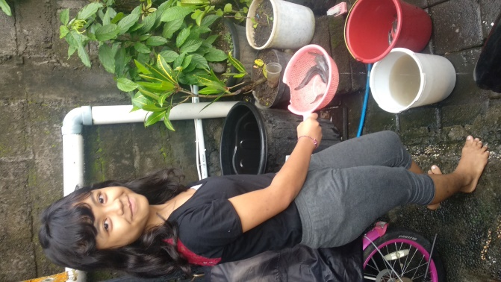 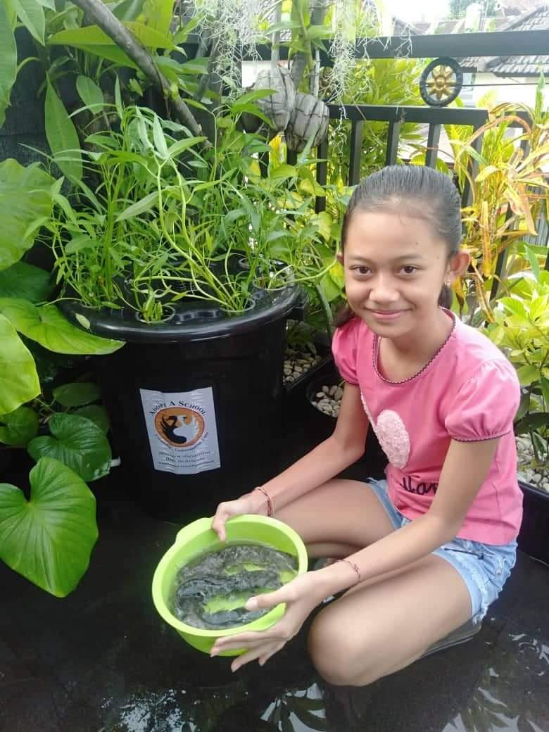 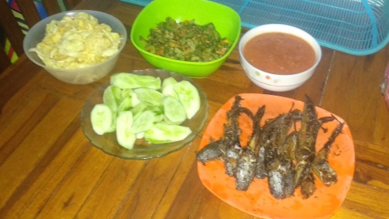

This project, so far, has proved to be worthwhile and Oka has been busy making a new batch of tanks for the students who have been placed on a waiting list and are very eager to join this programme. Not only is it providing food for a family, but giving students the opportunity to extend their knowledge of English and recording skills by reporting in writing direct to Oka. Thank you once again to the sponsors for making this possible.

Oka, with his family assistance, has been busy for months acquiring food, making up Food Aid parcels and delivering all over Bali. We will fund more in the coming weeks but insist he takes a short break for the moment. He has a lovely wife, five children ages from toddlers to teens and is a working teacher.

The Kaba Kaba team are very active and we hope to see Yuni back on deck soon. She is still unwell but starting to recover from the ongoing issues caused by Covid-19. She has been able to walk 50 metres in her Gang in recent days. We wish her well for continued improvement.

Andy Bracey and team of Global Village Foundation continue to work tirelessly in the mountains and areas surrounding Singaraja in the North and East of Bali. They not only deliver food, health care and clean water filters but have this last couple of weeks delivered and fitted about 50 wheelchairs from the voluntary organization Wheelchairs for Kids in Wangara, WA. You can see many photos on their Facebook pages.

Once again I would like to thank all our sponsors for their ongoing support. Your generosity has been amazing and the recipients in Bali are so very grateful.

Kind regards,

Sherryn Reid, AAS

Email: sherrynreid@hotmail,com

Mobile: 043.199.5357